 **17 Apr 2015** **The Weekly Bulletin of Rotary Club of Kathmandu Mid-Town** **bc-40/4.015**

|  |
| --- |
|  |

District: 3292 Web:www.rotarymidtown.org.np Club Id: 26776

**APRIL IS THE MAGAZINE MONTH**

**The purpose of the magazine is to advance the Object of Rotary in all its aspects.**



**Wishing you all a Happy New Year 2072**

Club’s Weekly Meeting # 1274 on Friday, 10 April:

Extracts of the Minutes :

“1. Pres Kul Chandra called meeting #1274 to order.

“3 Pres Kul Chandra welcomed members and guests: Ashley Hagar, Bikash,

Prashun Jalan, Meena Pande, and Bruno Malla.

“7. Club Admin Chair Bhairaja introduced the speaker Mr Maurizio Busatti

(Chief of Mission IOM). Mr Busatti spoke on the topic of `On Protecting

Irregular Nepalese Migrants`. Mr Busatti gave a sweeping view of the

global problems of illegal migrants. The problems are complex: who is

responsible when a state falls apart? Many migrants get into trouble by

simply not knowing or not being aware of what to expect. Also involved

are a long list of handlers, middlemen, `facilitators` and others who

ostensibly work for the migrants but who in fact are not there to help them

when it really counts. Nepal is signatory to many conventions including

the Palermo Convention against transnational crime, but enforcement remains difficult. He reiterated that migrants need better awareness, alternative employment strategies, and protection. There were a few questions after his talk and Pres Kul Chandra summed things up when he said, `we often look for easy solutions that do not hold ourselves accountable`. PP Arun gave the vote of thanks

”8. Information sharing:

> PDG Yogendra said that our Club`s choice for DG nominee 2017-18 (Mr Sanjay Giri) had been elected by a margin of some 12 votes.

> PP Komal updated on the status of TRF contributions. Overall, less than 10 Mid-Towners have taken the opportunity

to contribute this year.

> Pres Kul Chandra mentioned that the paperwork required for the Rotary District Awards for 2014-15 was due soon. He asked if anyone would be willing to volunteer to help with the submission. There were no immediate volunteers.

“9. Statistics of the meeting: Members present: 27”

# Weekly Meetings and Programs :

|  |  |  |
| --- | --- | --- |
| Date | Program/ Speaker | Topic of Presentation |
| 17 April | Mr Jie Tang | "Nepal: Transformation Plan for Hydropower" |
|  |  |  |

Weekly Meeting on Friday, 17 April:

Mr Jie Tang is our guest speaker for the day. He will give a talk on the topic “Nepal: Transformation Plan for Hydropower"

Mr Tang, an MBA from University of Cambridge, England has 29 years of experience working in large hydropower projects and other energy projects in developing countries

He joined the World Bank in 2001 as a young professional, energy specialist (2003), senior energy specialist (2005), lead energy specialist (2012), program leader (2014) covering the countries - Nepal, Bangladesh, Bhutan, Pakistan, Lao PDR, Cambodia, China, Vietnam, Thailand, Myanmar, Zambia, and Ghana.

He is currently the Program Leader for Nepal, Bangladesh and Bhutan, leading the World Bank programs in five business areas—energy, transportation, information and communication technology (ICT), public private partnership (PPP) and jobs—in these countries, with a focus on the energy business; shaping and managing Bank programs for (i) planning, policy, regulation, strategy, reform and institutional capacity building programs at the sector level, in close coordination with various development partners; and (ii) investment in hydropower, transmission lines, and distribution networks and renewable energy development.

Before joining the Bank, he had 15 years of work experiences with the China Three Gorges Project Corporation, at a number of technical and material positions.

He did his BSc in Electric Power Generation, Transmission and Distribution and Automatic Controls in 1985 from Wuhan University, China,

**Obama says he’s been mistaken for valet !**

He may be President now, but Barack Obama says he’s a black man who has been mistaken for the valet. Obama tells People magazine that every black professional male his age has had someone hand over their keys while waiting outside a restaurant. That happened to him, he said.

First lady Michelle Obama says her husband also used to have trouble catching cabs and once was mistaken for a waiter at a black-tie party. She says even when she went to Target as first lady, a fellow shopper asked her to get something from a shelf.

The president says racial relations have gotten better, but more progress is needed. He says the small indignities they have experienced pale in comparison to young men who have been mistaken for criminals just for being ‘dressed the way teenagers dress.”

*Source: The Himalayan Times*

**EVENT AT INDIAN RACETRACK NETS $350,000 FOR SERVICE PROJECTS!**

Rotary members in India selected a popular racecourse in Mumbai to promote Rotary to the tens of thousands of racing aficionados who gather there daily, raising more than $350,000 for club service projects in the process.

And between races, spectators at the Mahalaxmi Race Course were also treated to the Rotary members' attempt at a Guinness World Record as 650 members, 75 of them dressed in white and 575 in black, formed the shape of a horse - with the Rotary wheel as its eye - on the lawn of the members' area.

District leaders in western India chose the Mahalaxmi Race Course for their [Race for Humanity event](https://www.facebook.com/rotaryraceforhumanity) because it draws people from all segments of Indian society.

Leading up to race day, each club had raised at least $50,000 for the projects, which support literacy, children's health, and education, among other causes.

This was a spectacular event for Rotary in terms of fellowship, bringing together Rotarians and their families in one grand open-air venue.

The event not only helped raise funds for Rotary, strengthen district fellowship, and reinforce Rotary goodwill but it also highlighted Rotary's reach and network in society.

*Source: RI News*

Travel / Tourism

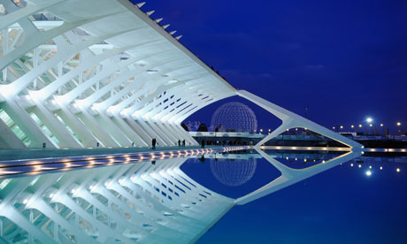

“The World is a book, and those who do not travel read only a page.”





**A THOUGHT FOR TODAY:**

**[Far and away the best prize that life has to offer is](http://www.brainyquote.com/quotes/quotes/b/baruchspin101666.html" \o "view quote)**

**[the chance to work hard at work worth doing.](http://www.brainyquote.com/quotes/quotes/b/baruchspin101666.html" \o "view quote)**[- Theodore Roosevelt](http://www.brainyquote.com/quotes/quotes/b/baruchspin101666.html" \o "view quote)**[.](http://www.brainyquote.com/quotes/quotes/b/baruchspin101666.html" \o "view quote)**

*[Courtesy: Rtn IsabellaC Bassignana Khadka](http://www.brainyquote.com/quotes/quotes/b/baruchspin101666.html" \o "view quote)*

On Lighter Side:

A father was trying to teach his son the evils of alcohol.

He put a worm in a glass of water and another in a glass of whiskey.

The worm in the water lived while the one in the whiskey curled up and died.

"All right son," said the father, "what does that show you?"

"Well dad, it shows that if you drink alcohol you will not have worms."

**Cellphone Way of Life !!**

(More features of ‘cellphone way of life’ to follow)

 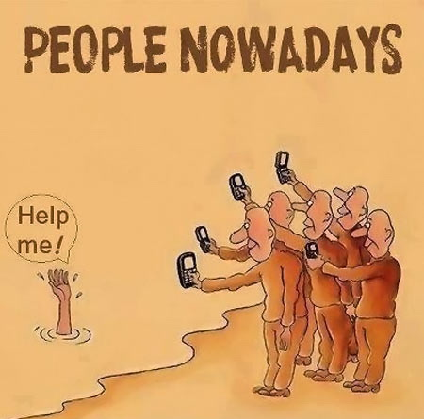

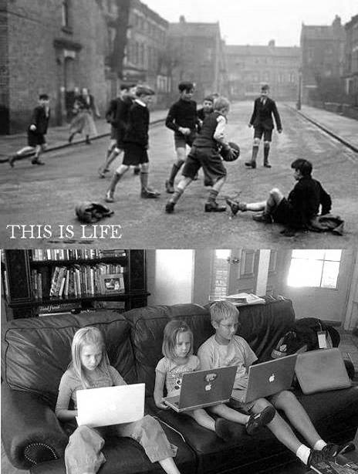 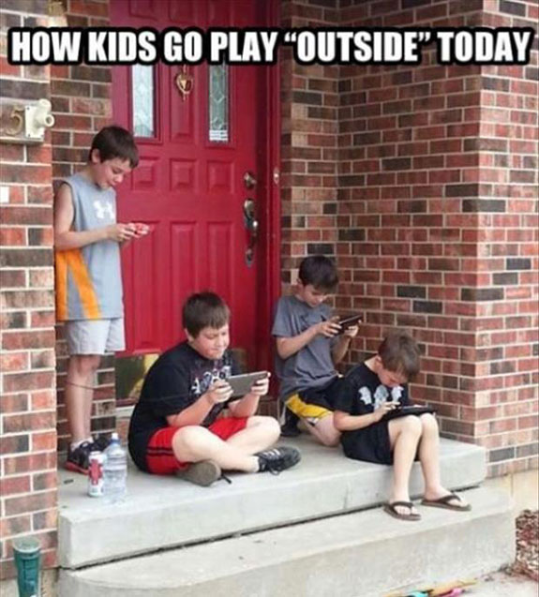

*Courtesy: Rtn Dr Isabella C.Bassignana Khadka*

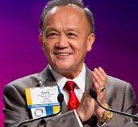

Our membership and services are what make Rotary powerful and strong. To keep it strong,

membership recruitment and retention have to be a priority for every incoming Rotary

leader.

**RI President GARY C.K. HUANG**

## 17 April 2015 The Weekly Bulletin of Rotary Club of Kathmandu Mid-Town bc-40/4.015

******************************************